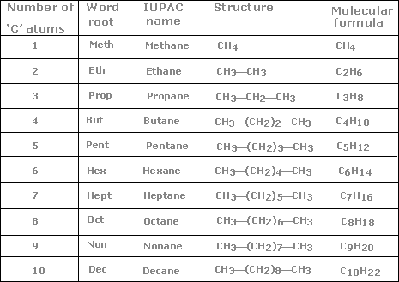

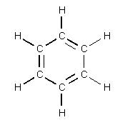
Benzene
Isomers – Have the same formula but different chemical structure.

Example cis-dichloroethene (C₂H₂Cl₂) vs, trans-dicholoroethane C₂H₂Cl₂

Cis means same side

Trans means opposite sides

H H H Cl
C=C C=C
Cl Cl Cl H

Organic Chemistry Info Sheet

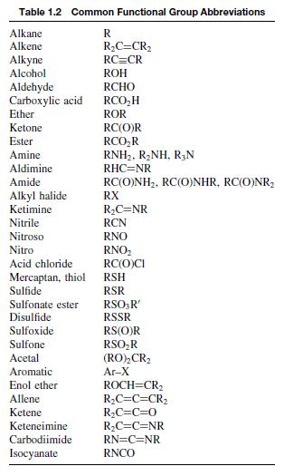

Functional Groups to know

Alcohol (R-OH) replace suffix (–ane) with (-ol)
Methane CH₄ becomes Methanol CH₃OH, a -H becomes –OH
Ethane C₂H₆ or CH₃CH₃ becomes ethanol CH₃CH₂-OH or C₂H₆O
Draw:

Alkene (double bonded C) suffix (-ane) becomes (-ene)
Propane C₃H₈ becomes propene (C₃H6)
Draw:

Alkyne (triple bonded C) suffix (-ane) becomes (-yne)
Butane C₄H₁₀ becomes 2-Butyne C₄H₆
Draw:

Aldehyde (doubled bonded oxygen at the end of the chain) suffix becomes –al
Pentane becomes pentanal
Pentane C₅H₁₂ becomes C₅H₁₀O
Draw:

Carboxylic Acid (double bonded oxygen and –OH on the end carbon) suffix becomes –oic acid
Ethane becomes Ethanoic Acid (also called acetic acid or vinegar)
Ethane C₂H₆ becomes C₂H₄O₂ or CH₃COOH
Draw:

Ether (oxygen in the middle of the chain) For naming, the longest chain is the parent chain
Methoxyethane (or ethyl methyl ether) CH₃CH₂OCH₃
ethoxypentane (or ethyl pentyl ether) CH₃CH₂OCH₂CH₂CH₂CH₂CH₃
Draw:

Ketone (oxygen double bonded to a carbon in the middle of a chain) end becomes –one
Butane becomes 2-Butanone (the 2 tells you which carbon has the oxygen)
CH₃CH₂CH₂CH₃ becomes CH₃COCH₂CH₃
Draw:

Ester (A carbon in the middle of the chain is bonded to a double bond oxygen and an oxygen, the oxygen is then bonded to the next carbon in the chain

Ethylpropoanate

CH₃CH₂COOCH₂CH₃
Draw:

